**TASK 5 –Maven Creation**

**Step 1: Creating folder**

Create a folder and clone the repository

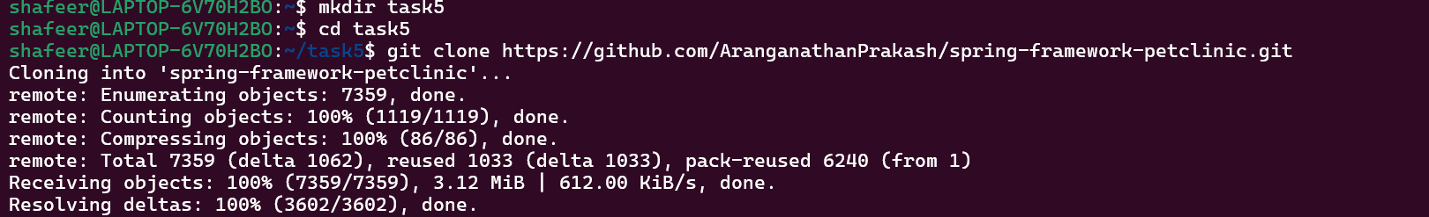

**Step 2: Installing maven**

Installing maven using -- sudo apt install maven

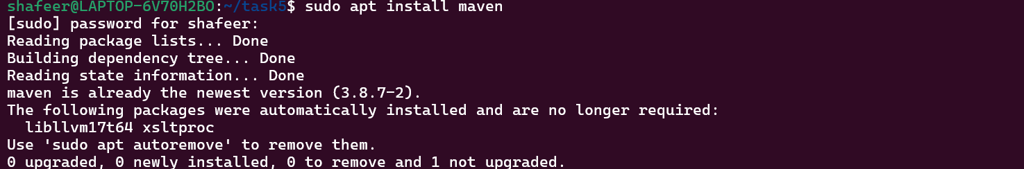

**Step 3: Checking**

See if the maven is installed or not

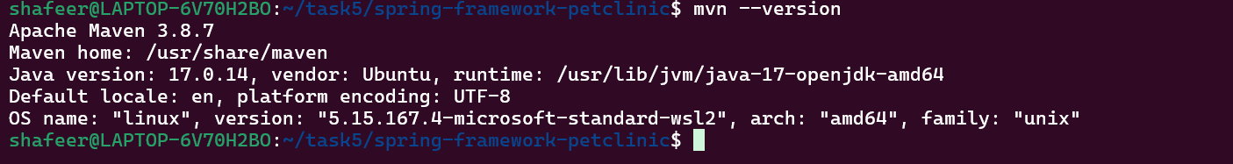

**Step 4: Testing**

Test the maven

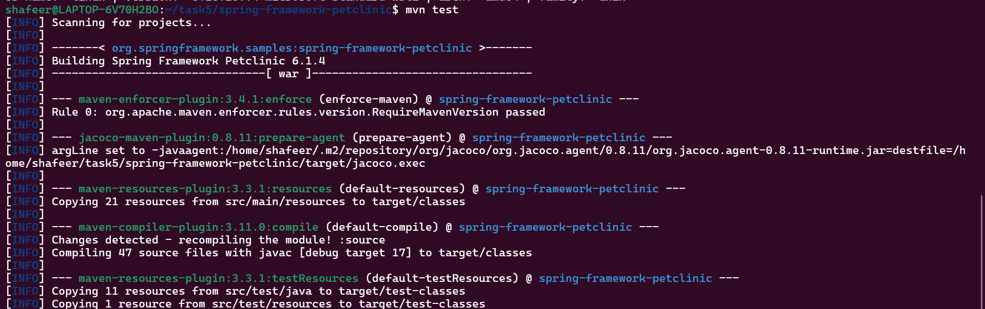

**Step 5: Clean**

Clean the maven

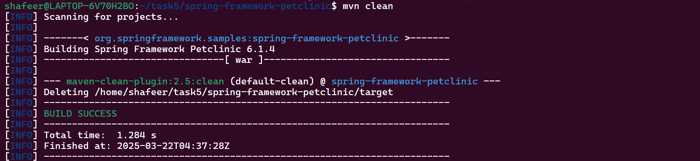

**Step 6: Install the Required dependencies**

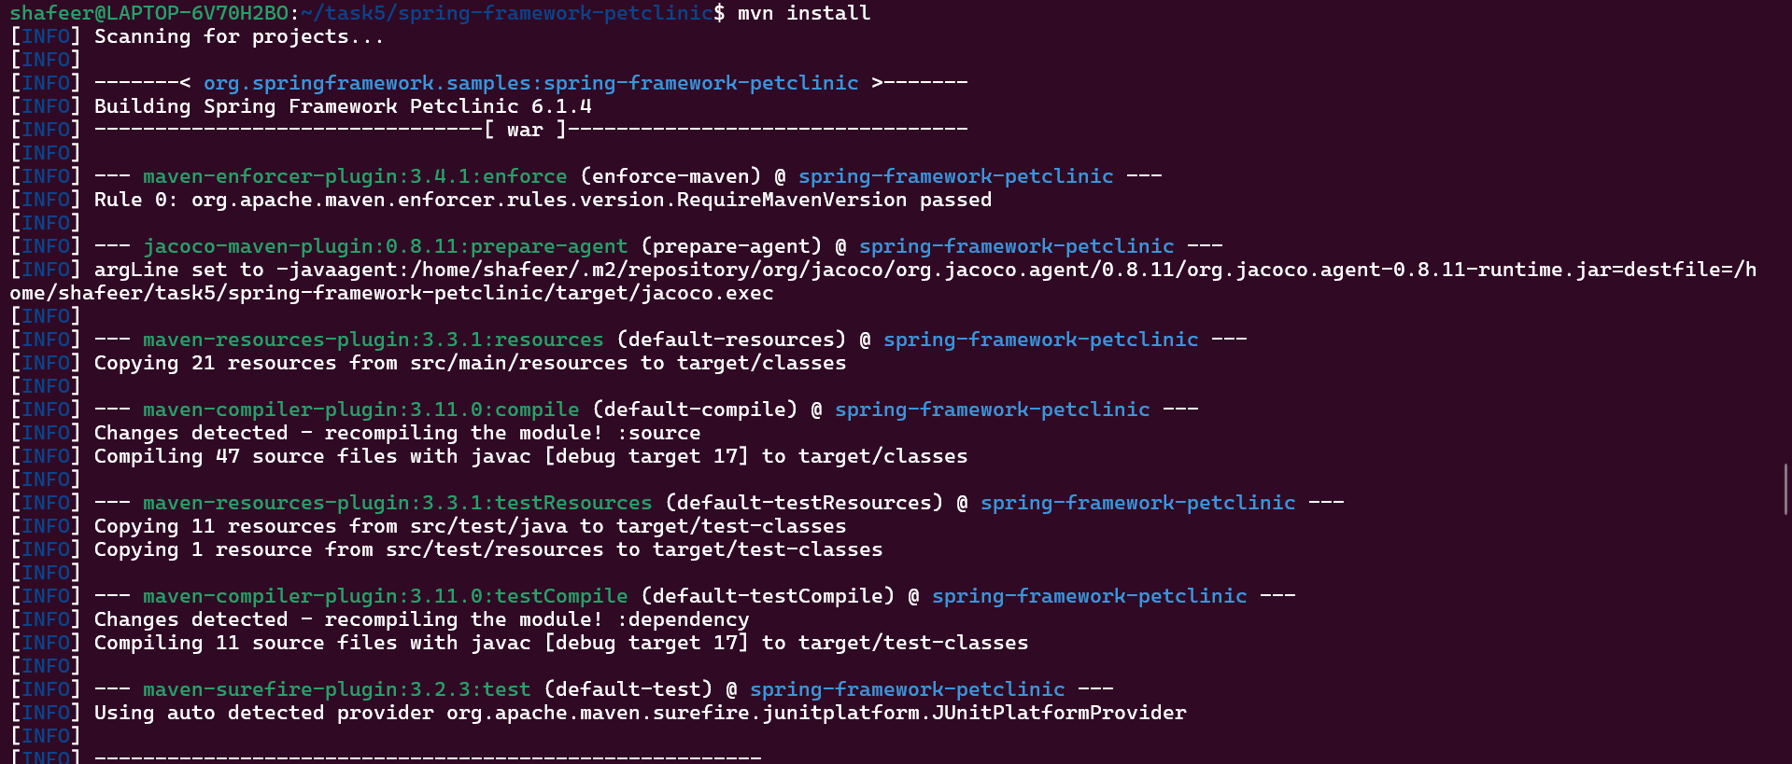

**Step 7: To package the project into a .war file**

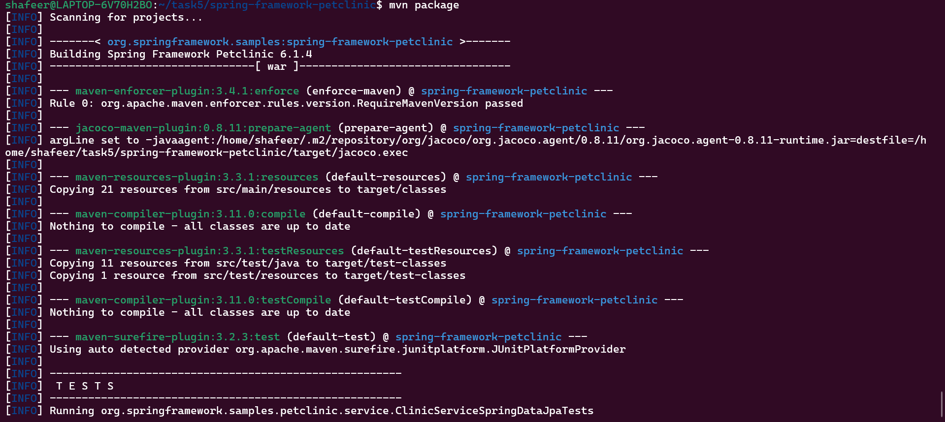

**Step 8: Build a docker image**

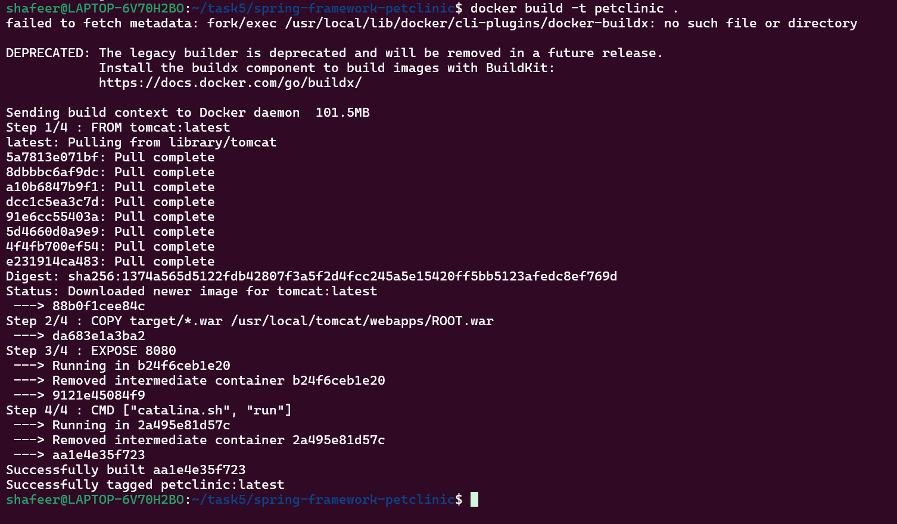

**Step 9: Login in docker**

Login in the docker using the username  


**Step 10: Give a tag name for the image**

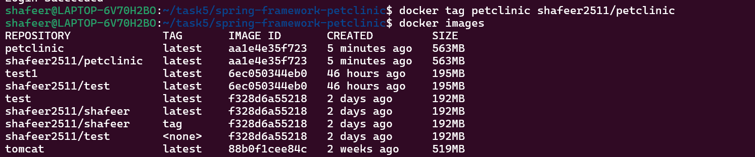

**Step 11: Push**

Push the image inside the docker

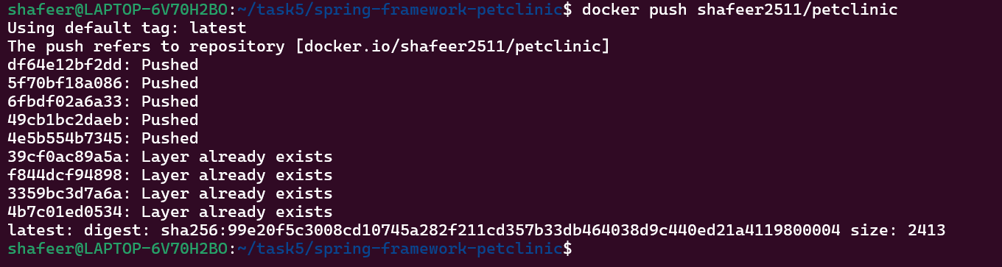

**Step 8: Minikube**

Start the minikube

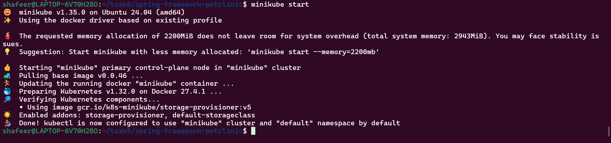

**Step 9: Deployment creation**

Create a deployment named petclinic



**Step 10: Deployment exposure**

Expose the deployment in the kubectl



**Step 11: Service**

Check the service of the petclinic webpage

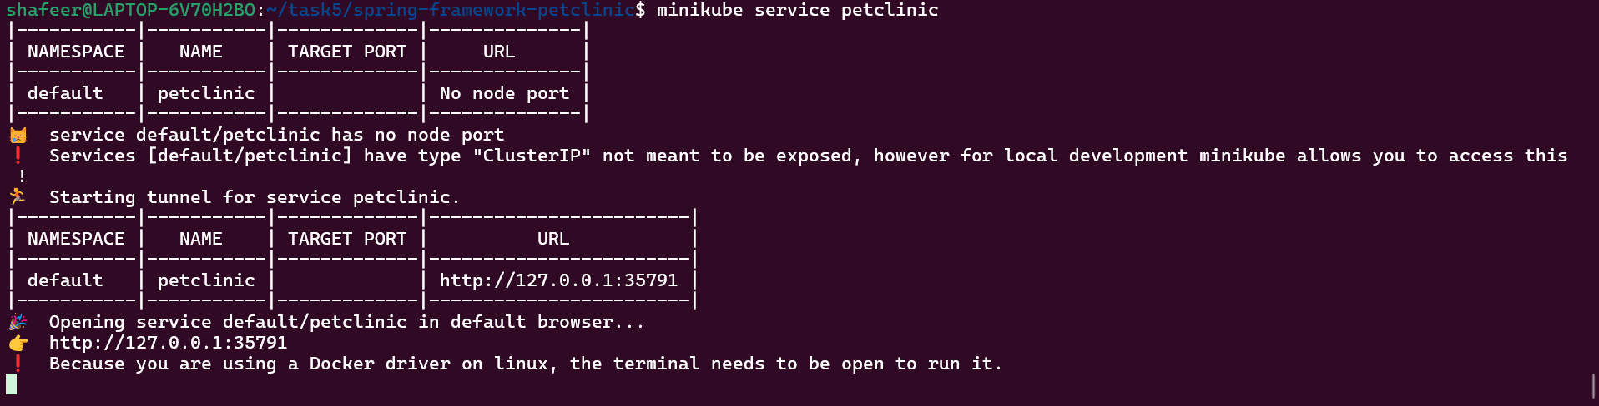

**Step 12: Output**

The output page is displayed in the http://127.0.0.1:35791

